AWS DevOps

DAY - 1

Why DevOps?

DevOps is a methodology in SDLC (Software Development Life Cycle)

* Waterfall
* Agile
* DevOps

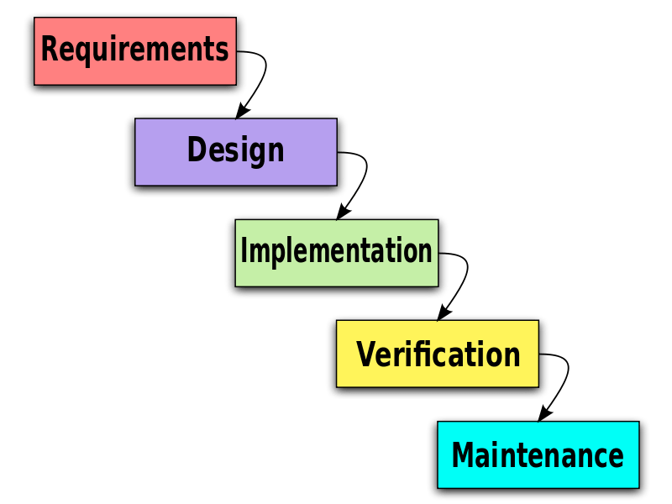Waterfall Agile

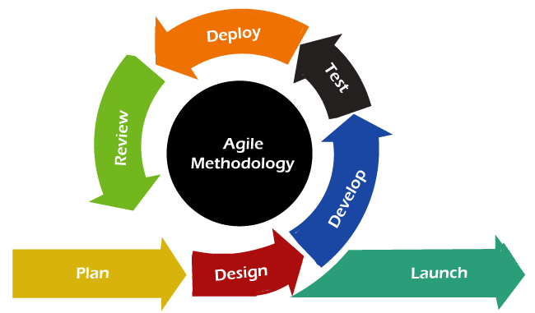

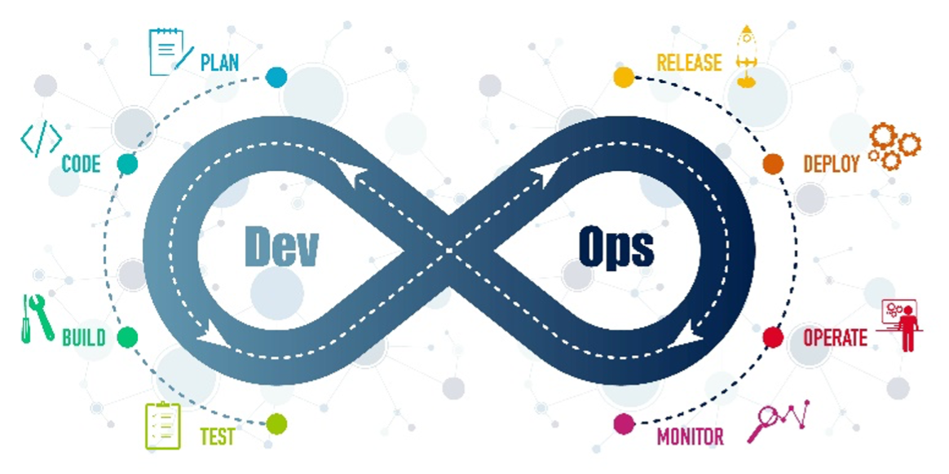DevOps

MODULE - I (20 Days)

1. git
2. github
3. Maven
4. Jenkins we can do a mini project
5. Sonar Qube
6. Nexus
7. JUint
8. Tomcat
9. git (Version Control)

Which stores the history of data like modified date, created date, user info etc.

1. github

To store the data & to access the data remotely.

1. Maven (Build Tool)

It is build tool which is converts the data from human understandable language to machine understanding language (Binary conversion). Which is developed by Tomcat

1. Sonar Qube

This is used for Code Quality Analysis

1. Jenkins

It is an open source automation server. It helps automate the parts of software development related to building, testing, and deploying, facilitating continuous integration and continuous delivery Continuous Integration & Continuous Delivery / Deployment

1. Nexus

It is a repository which is used to store the Artifacts (Ex. .exe files)

1. Junit

It is used for testing

1. Tomcat

It is an application server

MODULE – II (7 Days)

Docker

It is a company, which provides container technology, to convert Files (Artifacts) as images.

* Container Related Commands
* Image related commands
* Docker files
* Docker compose
* Docker Swarm
* Docker Networking
* Docker Hub

MODULE – III (10 Days)

Cloud (AWS / AZURE / GCP..etc) Services

1. EC2 (Elastic Cloud)
2. VPC (Virtual Private Cloud)
3. IAM (Identity & Access Management)
4. Load Balancer
5. Auto Scaling
6. S3 (Simple Storage Service)
7. RDS (Relational Database Service)
8. EBS (Elastic Block Store)
9. ES (Elastic Search)
10. ECR (Elastic Container Registry)
11. EKS (Elastic Kubernetes Service)
12. Cloud Watch
13. SNS (Simple Notification Service)
14. SQS (Simple Queue Service)
15. KMS (Key Management Service)
16. Route 53
17. Lambda

MODULE – IV (7 Days)

Kubernetes / K8S

It is an open source container orchestration system, which is used, or automatic software deployment, scaling & management

MODULE – V (2 Days)

Grafana & Prometheus (Monitoring Services)

MODULE – VI (4 Days)

Ansible (Provisioning & Configuration Management & Application Deployment functionality)

MODULE – VII (Mini Project)

Terraform

IAC (Infrastructure As Code)

MODULE – I

2. github

* Create a github account (<https://github.com/ssglearnings/ssgp1>)
* Open gitbash
* Type the following commands (one time configuration)
  + $gitconfig --global user.name “ssglearnings@gmail.com”
  + $gitconfig --global user.name “ssglearnings”
  + $gitconfig –list

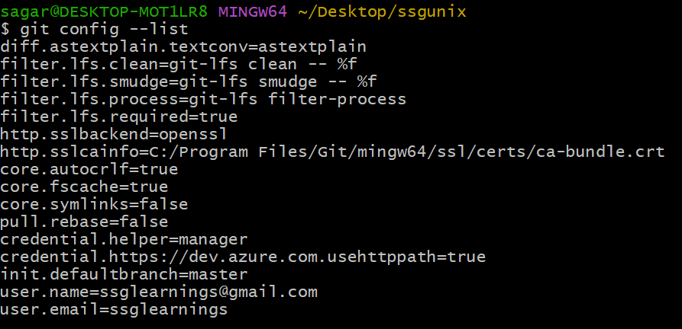

* gitclone ( to download the remote repository to the local machine)
  + $gitclone <https://github.com/ssglearnings/ssgp1.git>

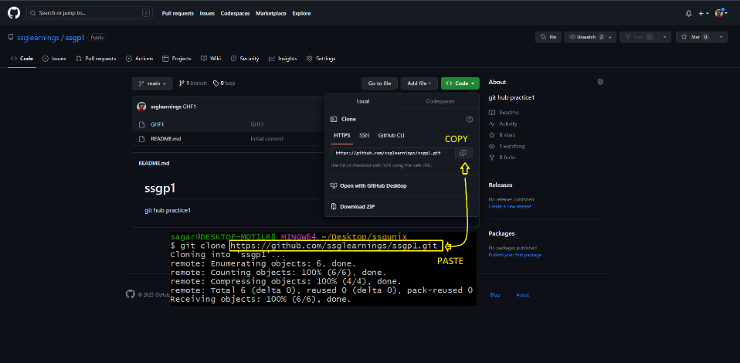

* + $gitstatus

If we get below error

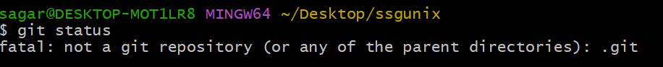

Do this

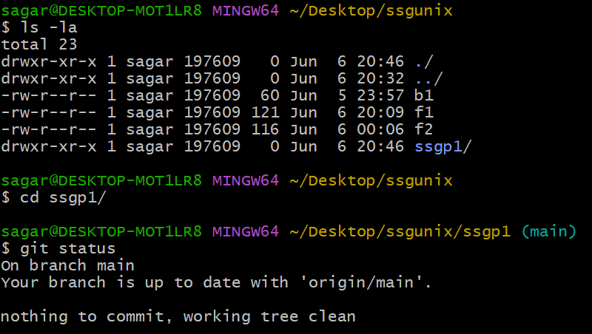

Working directory (red)

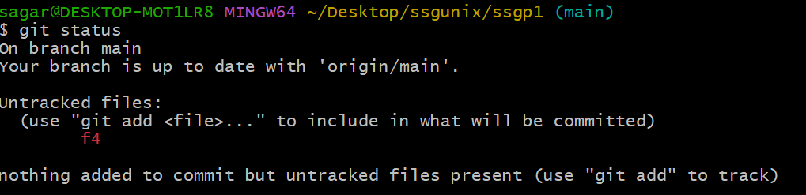

* + $git add .

Staging area (green)

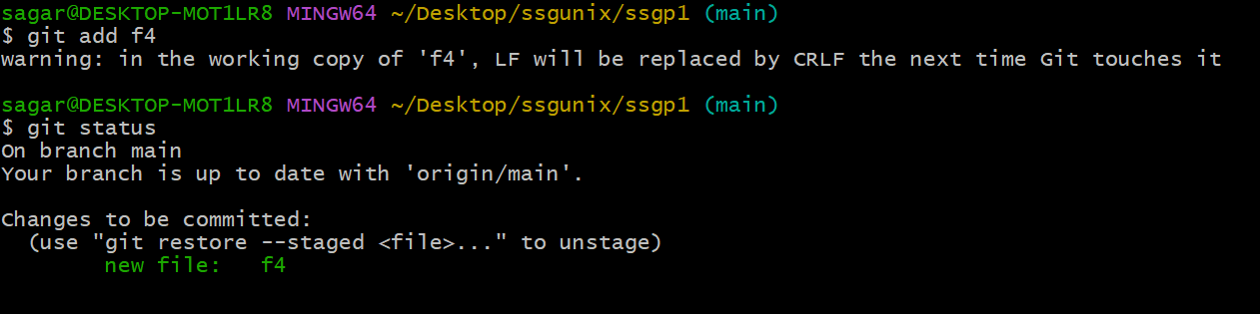

* + $git commit –m “message”

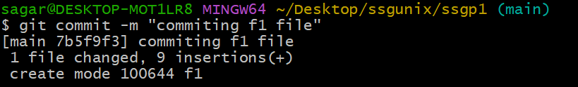

* + $git log

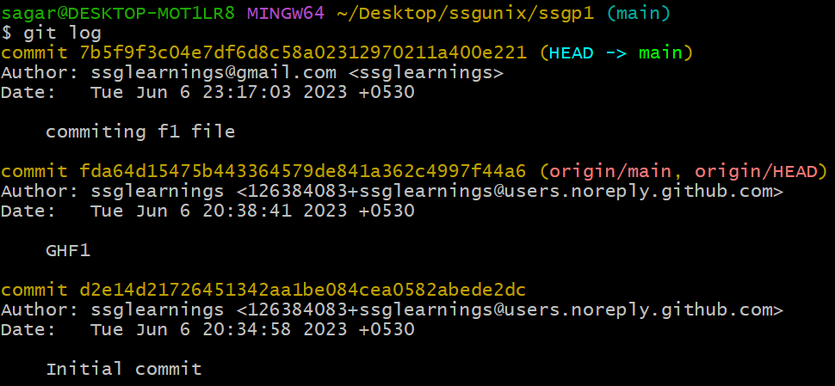

* + $git push (to upload files from local to remote)

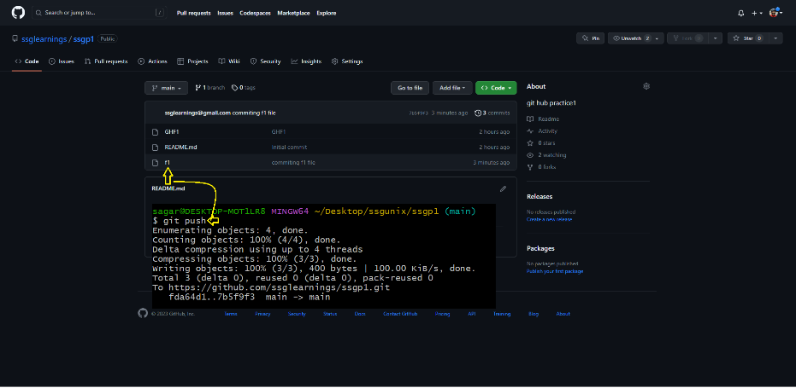

* + $git pull (to bring files from remote to local)

